**GitLab Instructions**

1. Please navigate to <https://gitlab.com/users/sign_in>
2. Check out Register tab and fill in all the details, please use your Uno Email address.

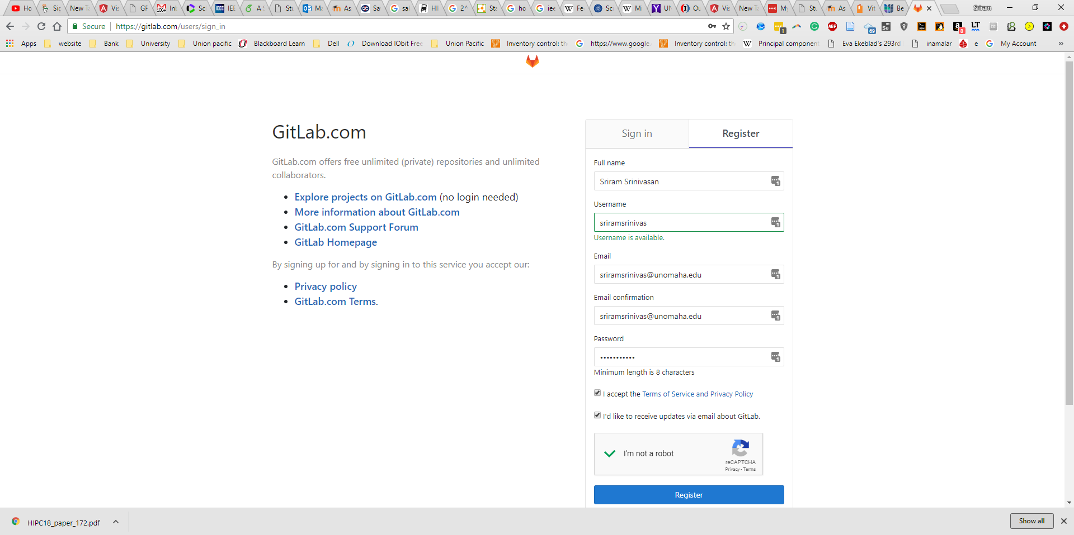

1. If you are successful with step2, you should see a message something like this-

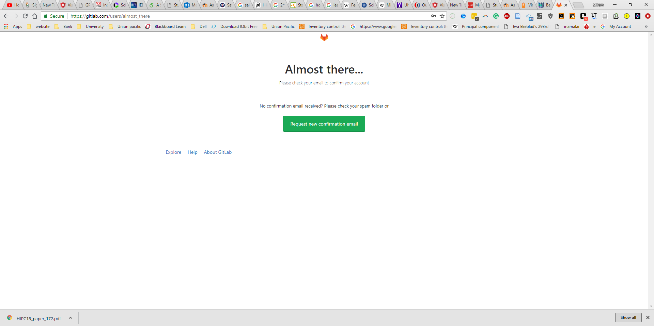

1. Please check your Email and confirm your account. If you didn’t receive an email from GitLab, please check spam folder.
2. Now if you are done with step4, you have created your GitLab account, great you have completed the first section of this lab. Next, we will create a private repository and add my email to give me access to the repository. The next section of this lab is important if you fail to do this, I won’t be able to grade your assignments and lab.
3. After step4, you are recommended to login to Git Lab with your credentials. After you log in, you should see the welcome page.

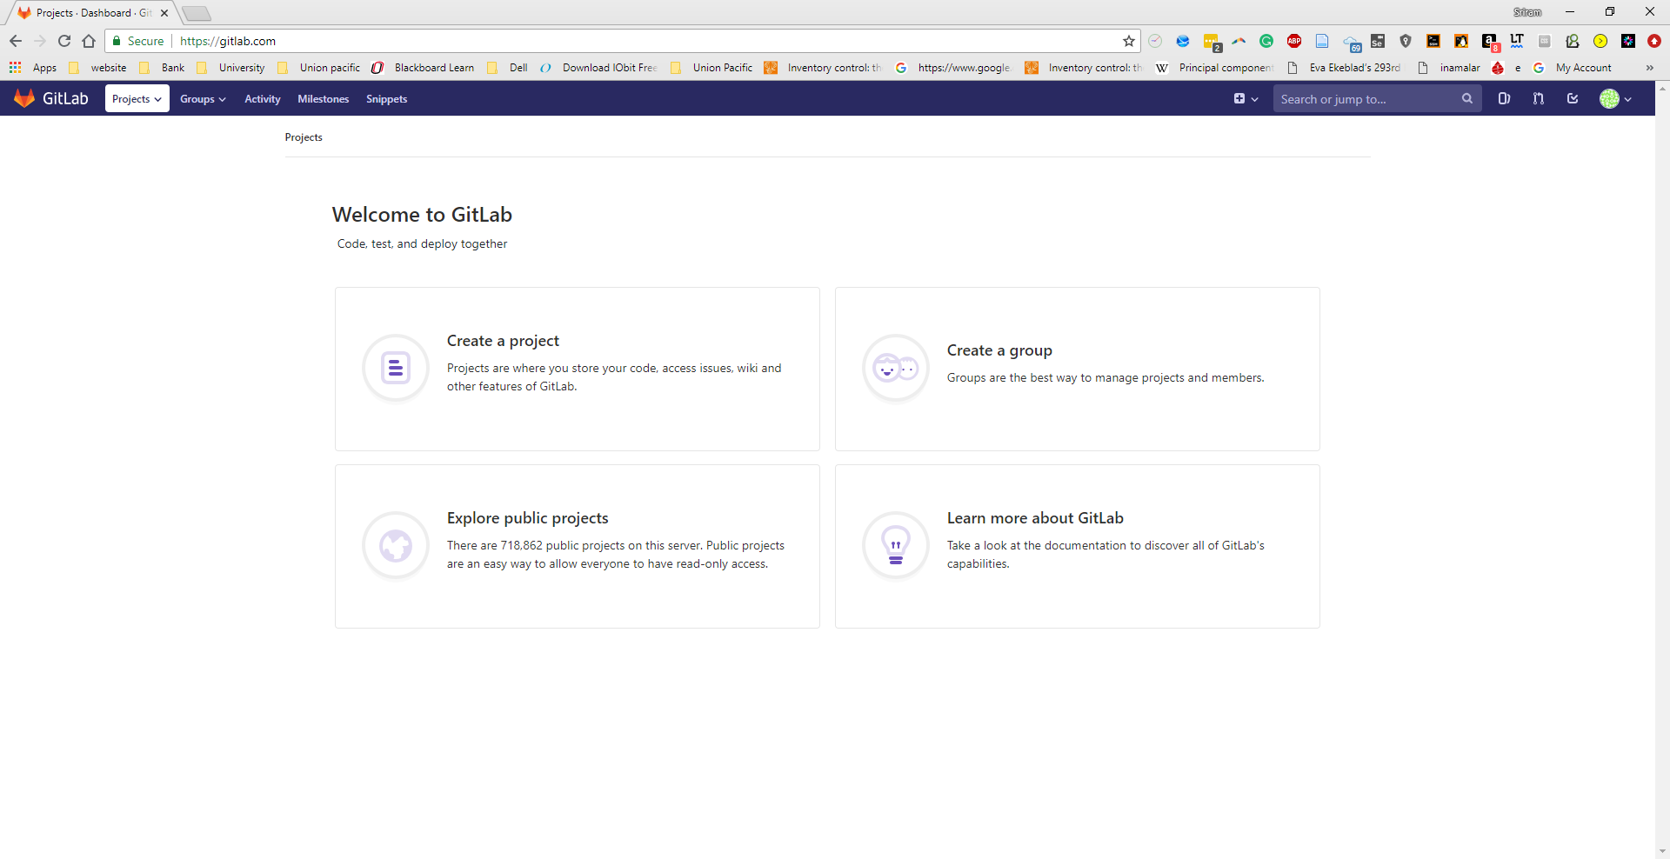

1. Now in the welcome page, click create a Project name “CIST1300-001” without quotes and make the project private. The reason we choose private is because all your assignments and lab shouldn’t be accessed by anyone unless you have authorized them to access your repository. You can also check the box which says to ”**Initialize repository with a README”.**

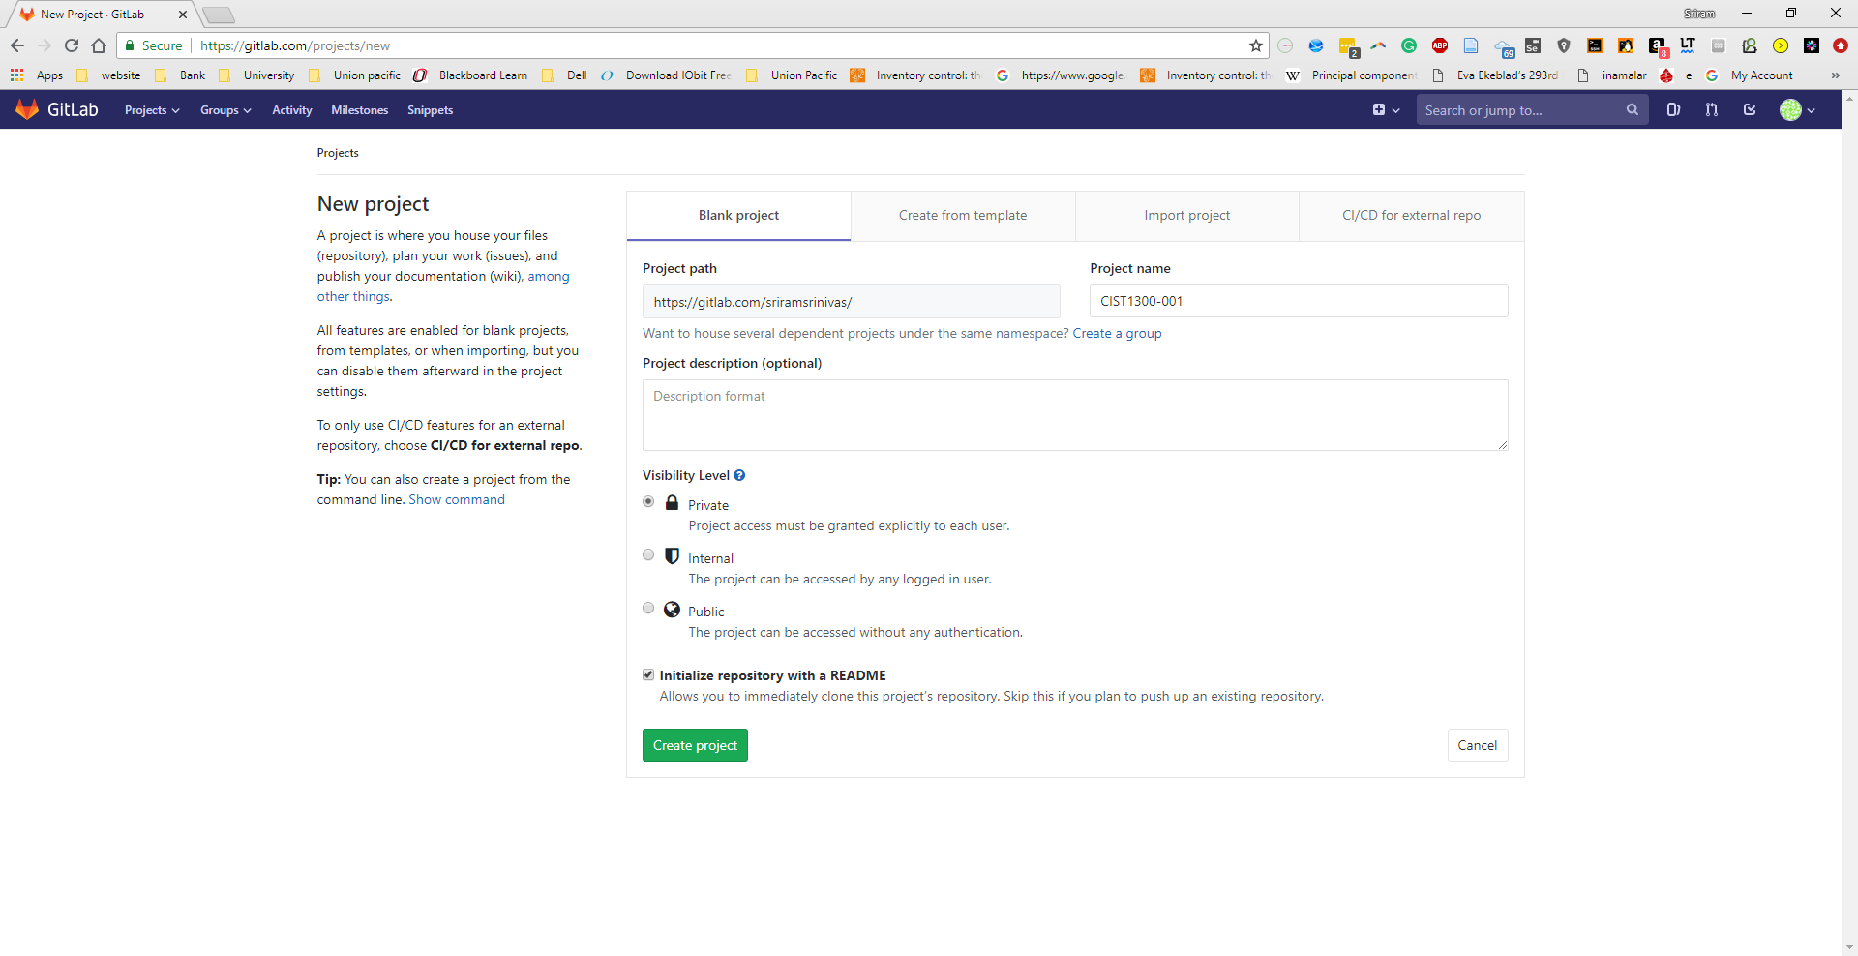

1. **Once you hit the hit the create project button you should see something similar.**

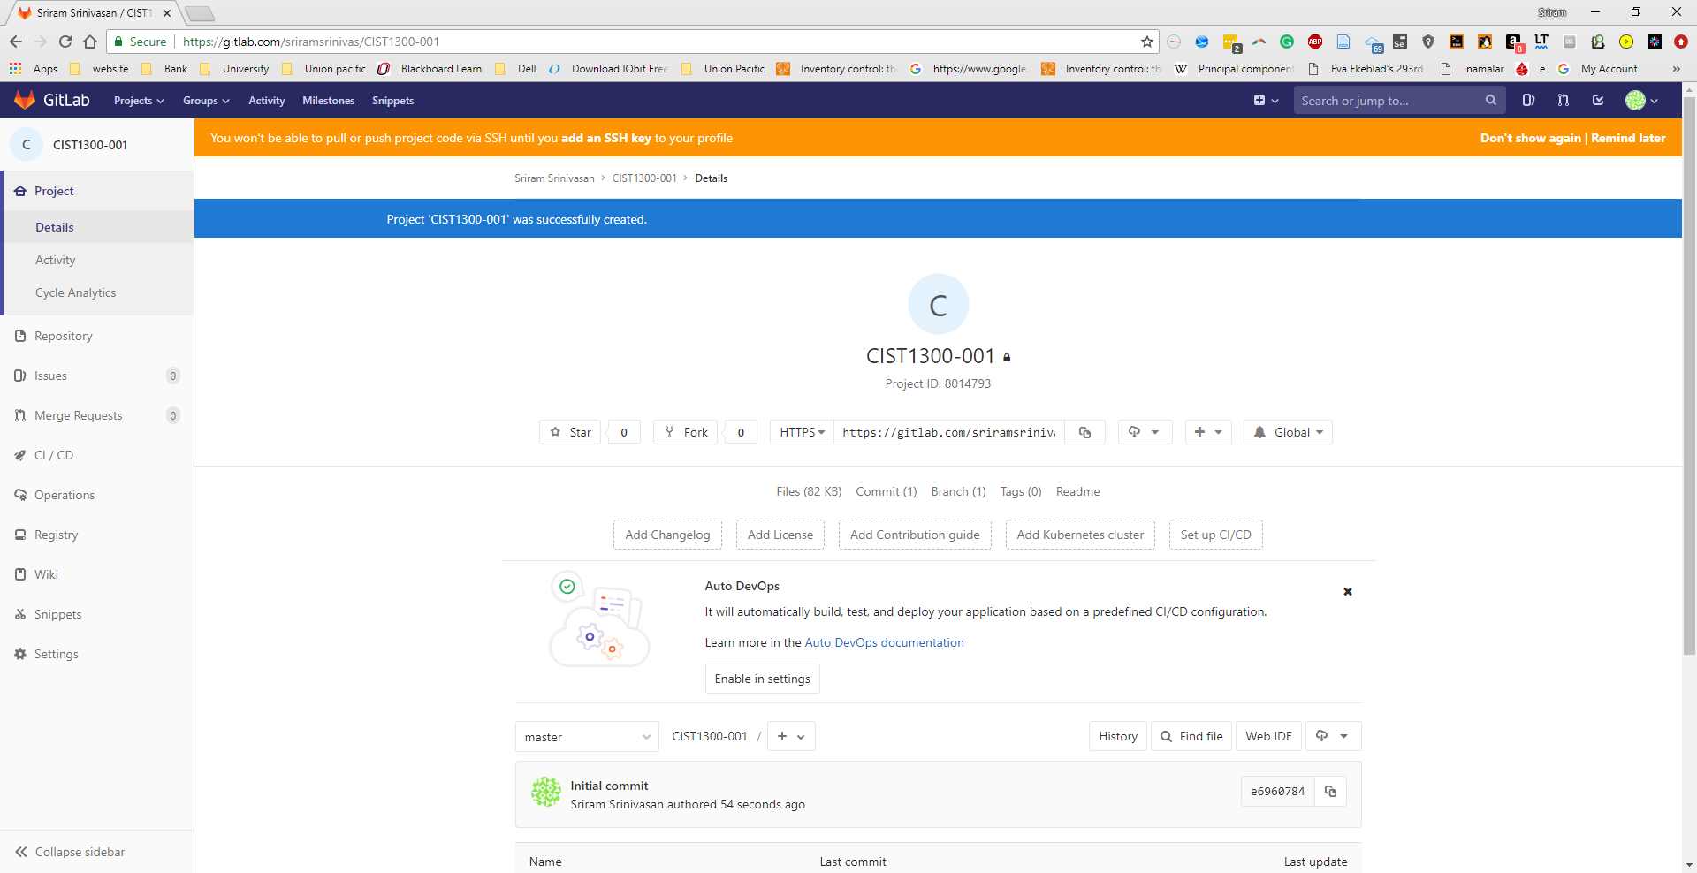

1. **Now please give me access to your private repository, please click settings on your left side, and click “Members”. Now in Add member type Sriram Srinivasan@sriramsrinivas.**

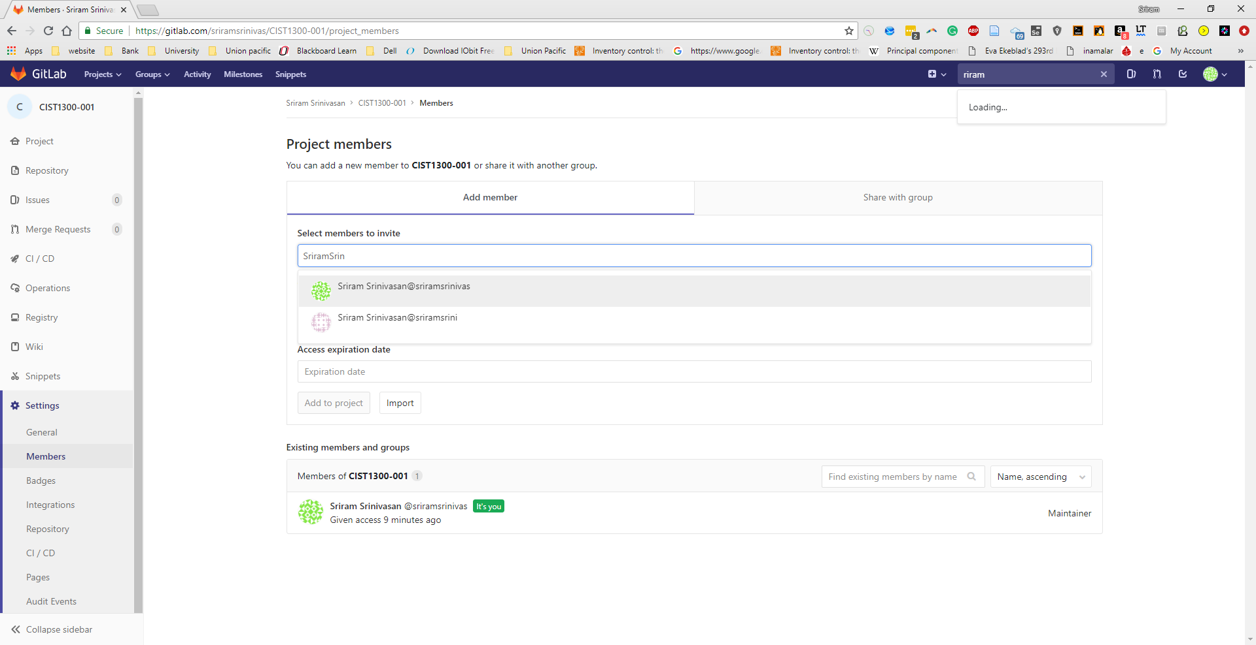

1. **In roles please provide me Maintainer roles so that I can see your assignment submissions and grade them. You can set an Access Expiration date to 12/31/2018. The expiration date is optional, however, if you provide 12/1/2018 or before I can’t grade your assignments after that date so please have the access date at least till 12/31/2018 or after.**

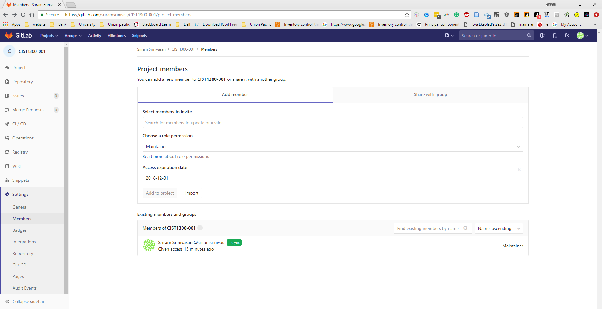

**You can remove me any-time, but remember if you remove me I can’t grade your assignments and labs and you need to provide me access again.**

1. **Congratulations, now you have created your first Git repository for this class. If you complete step10, you have completed lab1 and this setup will be used for the entire semester. For all your assignments and labs you are recommended to push your code to your CIST1300-001 repository.**

**In lab2, we will link Loki system with GitLab.**